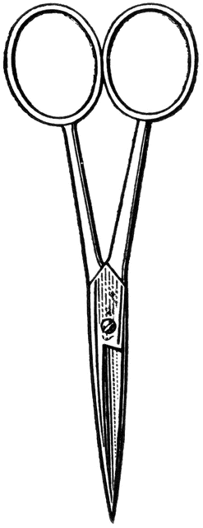

Dissection 101: Clam
PowerPoint Quiz (student)
Clam Dissection Quiz: Complete the following questions.

- Which of the following is the ventral side of the clam?
Side: A B C D (circle one)

- Name the location indicated on the shell? Umbo

- Name the structure indicated above. Adductor muscle

- What is the function of this structure?
Muscle relaxes – shell open
Muscle contracts – shell closes

- Name the structure indicated. Gills

- What is the function of this structure?
Respiration – oxygen/carbon dioxide exchange

- Name the structure indicated. Foot

- What is a function of this structure?
Used to sort food and move it toward the mouth for digestion

- Name the structure indicated. Heart

- What type of circulatory system does the clam have?
Open system Closed system (circle one)

Provided by
Dissection 101: Clam
PowerPoint Quiz Continue (student)
- Describe how the clam’s circulatory system compares/contrasts to the human circulatory system.
Clams have an open circulatory system; humans have a closed circulatory system. Both systems move blood throughout the organism providing exchange of nutrients/oxygen for waste products/carbon dioxide, at the cellular level. The open system of the clam is not complete; blood pools around the heart, as a result there is less pressure. The blood of the closed system like humans is confined within the blood vessels and heart, resulting in a high pressured system. The high pressure system allows for a higher level of activity.
- Name the structure indicated. Mantle

- What is a function of this structure?
Produces the shell and provides protective and lubricated surface for the body structures.

- What is the function of the green section indicated?
Digestive glands – produce enzymes to break down the food to release nutrients.

- Name the tube-like structure indicated. Intestine
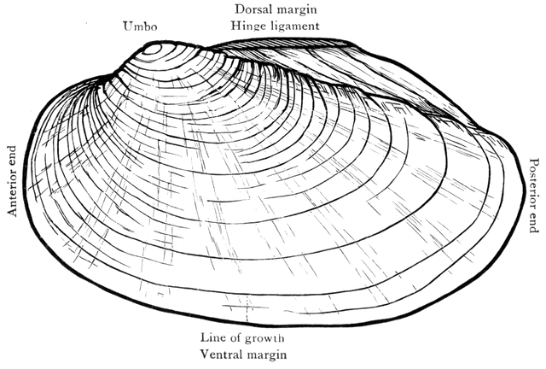
Provided by

