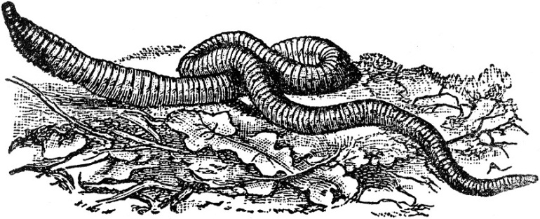
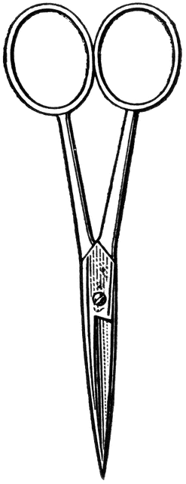
- Lesson Plan: Earthworm Dissection

Dissection 101:
The Earthworm
Background: The earthworm is an invertebrate in the phylum Annelida; it is a segmented worm. The segments are distinguished on the exterior by noticeable band-like-rings; internally the segments are separated by septa. Posterior sections of the worm can be lost and survival is possible, many times with regeneration. There are tiny hair-like structures on the segments called setae which aid in movement. Circular muscles are used to reduce the circumference of the earthworm, increasing the length of a section. The setae secure the section and then longitudinal muscles contract reducing the length of the worm, which results in the characteristic seesaw-like motion.
There is a noticeable exterior belt/Band-Aid like section toward the anterior end called the clitellum. The clitellum produces a slime-like tube which forms the cocoon. Earthworms are hermaphrodites/monoecious having both male and female sex organs. Most earthworms require another worm to reproduce. Sperm from the mate is stored in the seminal receptacles of the worm. A slime tube is produced by the clitellum and passes over the worm collecting the eggs and the stored sperm from the mate. The eggs are fertilized in the slime tube which slides off of the worm and forms a cocoon for the fertilized eggs.
The earthworm has a complete digestive system with a mouth, anus and specialized structures with specific functions. The earthworm has a crop for food storage, similar to our stomach, a gizzard for grinding food and a long intestine for digestion/nutrient absorption. They are deposit feeders, aerating and regenerating the soil as they pass through.
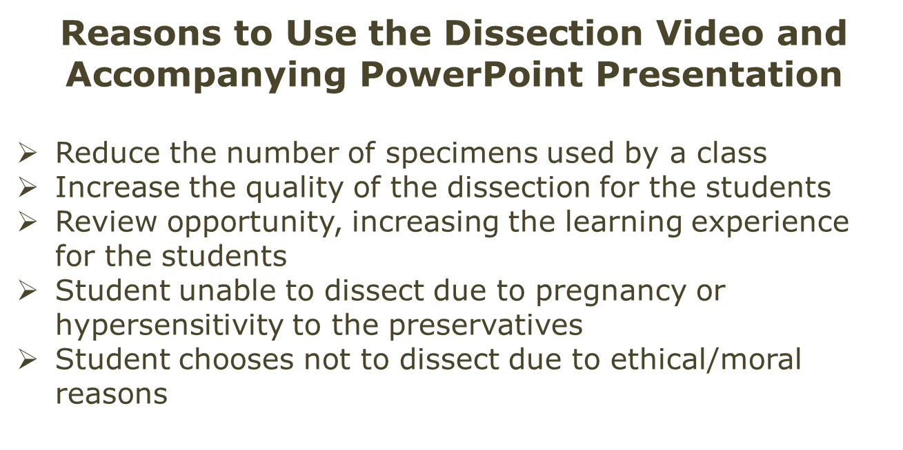
The earthworm exchanges oxygen and carbon dioxide through their damp/moist skin. The earthworm has a closed circulatory system consisting of three main sections. The dorsal and ventral blood vessels carry blood throughout the worm. The aortic arches, which are found near the anterior end of the worm, aid in pumping/pressure regulation. They are commonly referred to as the heart.
Images courtesy FCIT, http://etc.usf.edu/clipart

Are you looking for more science resources?
Visit Old School Demonstrations at
http://www.sdpb.org/scienceiq (Click)
Dissection 101:
The Earthworm (continue – page 2)

Materials:
- Earthworm dissection PowerPoint (show) (Wait for the “Click” sign in lower right corner)
- Earthworm quiz PowerPoint (show) (Handout: Teacher/ Student)
- Preservative MSDS for reference
Advance through the PowerPoint slides slowly for the PowerPoint presentations to work properly.
(Wait for the “Click”)

- Eyewash station available
- Shower available
- The following are for each student, pair or group.
    - Dissection tray and pointer
    - Dissection scissors
    - Scalpel
    - Eye protection
    - Protective clothing (apron, lab-coat)
    - Gloves (latex free)
    - Earthworm identification Handout
(One for use in lab, extra copy for reference)
    - Earthworms
      - Example biological suppliers
        - WARDS (http://wardsci.com)
        - Carolina (http://www.carolina.com)
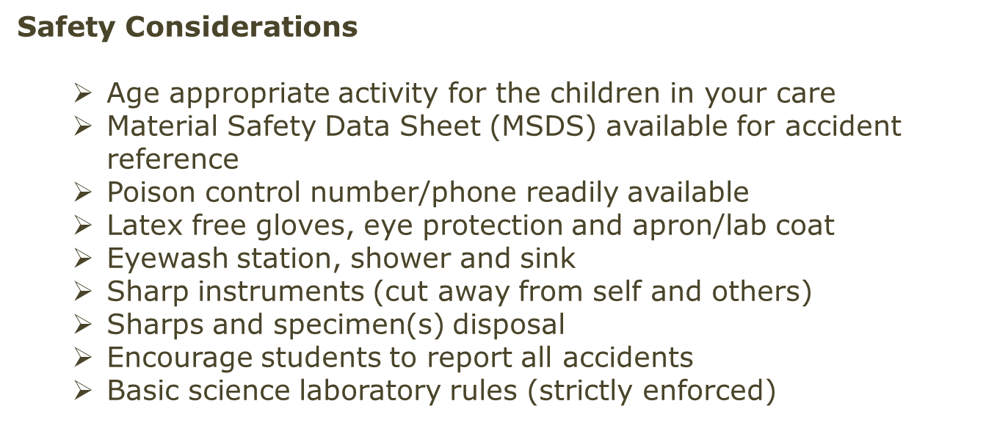

Procedure:
  - The teacher should view the accompanying dissection Video.
(The video is not designed to be viewed by the students; it is designed for the teacher to review the dissection. The students may view the video if appropriate/necessary. Student video clips are in PowerPoint.)
    - Video time code:
    - Time: 00:00 to 07:00 – Background information/orientation
    - Time: 07:01 to 20:41 – Dissection
  - Gather the materials listed above.
    - Include the interactive PowerPoint (show) presentation for the laboratory projector/screen.
Are you looking for more science resources?
Visit Old School Demonstrations at
http://www.sdpb.org/scienceiq (Click)
Dissection 101:
The Earthworm (continue – page 3)

  - Review safety concerns/rules with students.
  - Lead the dissection by advancing through the PowerPoint (show) presentation; the students should identify the parts shown.
  - The students should check off the earthworm parts on the student Handout once they are identified. An extra, clean copy should be given to the students for review.
  - Clean the laboratory and dispose of specimens properly.
  - Quiz the students during the next class period.
    - Save the earthworms and pin the actual parts.
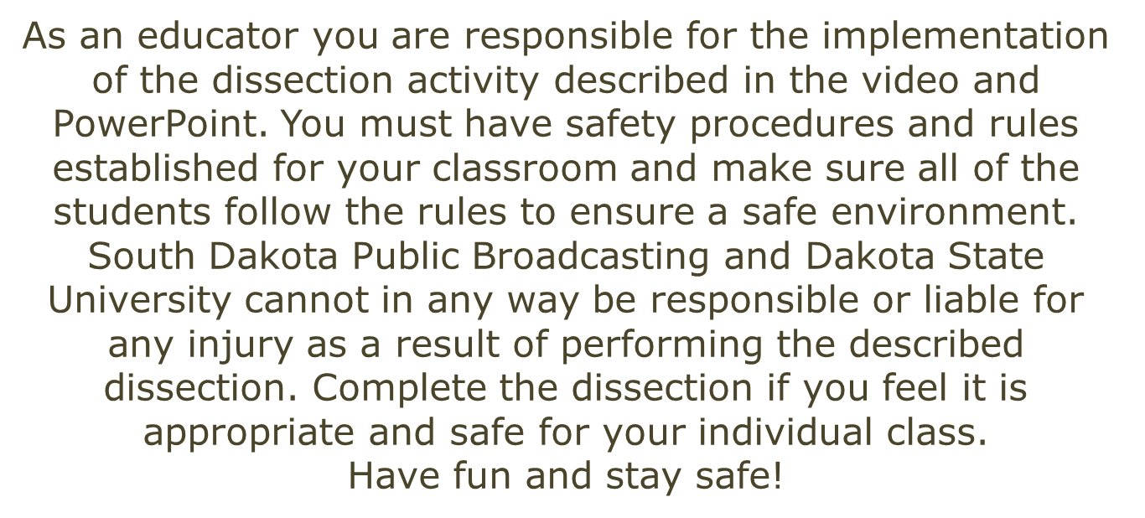
    - Earthworm quiz PowerPoint (show) (Handout: Teacher/ Student)

Are you looking for more science resources?
Visit Old School Demonstrations at
http://www.sdpb.org/scienceiq (Click)

