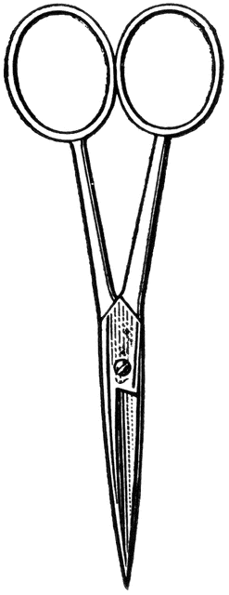

Dissection 101: Earthworm
PowerPoint Quiz (student)
Earthworm Dissection Quiz: Complete the following questions.

- Which earthworm above is displaying the ventral surface?
Earthworm: A B (circle one)

- Name the structure indicated? ____________________

- What is the function of this structure?
________________________________________________________________________________________________________________

4. What is the dark, black material shown above? ____________________

5. Name the structure indicated. ____________________

6. What type of circulatory system does the earthworm have?
A. Open system B. Closed system (circle one)

7. Name the structure indicated. _______________

8. What is the function of this structure?
________________________________________________________________________________________________________________

9. Name the structure indicated. _______________

10. What is the function of this structure?
________________________________________________________________________________________________________________

11. Gender - viewing the earthworm below; which of the following is correct?
A. Female B. Male C. Both (circle one)

12. Name the structure indicated. _______________

13. What is a function of this structure?
________________________________________________________________________________________________________________
Provided by
Dissection 101: Earthworm
PowerPoint Quiz Continue (student)

14. Which system is this structure associated with?
A. Digestive B. Nervous C. Reproductive D. Circulatory (circle one)

15. Describe the movement of the earthworm using the following terms.
(Setae, circular muscles, longitudinal muscles, segments) _______________________________________________________________________________________________________________________________________________________________________________________________________________________________________________________________________________________________________________________________________________________________________________________________________________________________________________________________________________________________________________________________________________________________________________________________________________________________________________________________________________________________

Provided by

