Old School Science Demonstrations!

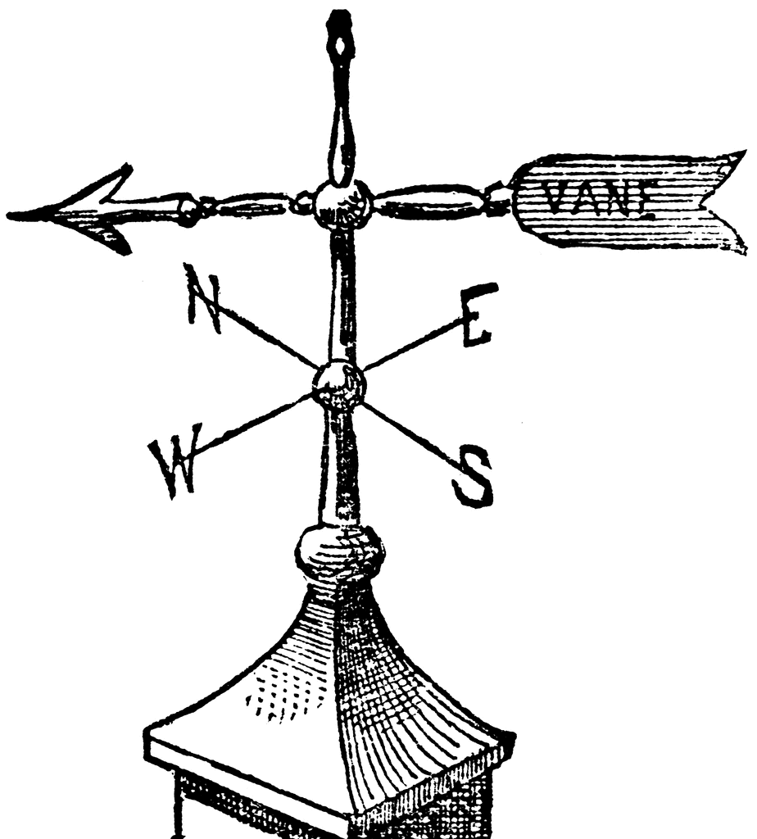

Image courtesy FCIT, <http://etc.usf.edu/clipart>

Demonstration Name: Bernoulli's (air) Tube

Concept: Matter, air flow, fluid

Materials:

* Plastic tube
  + Different names, depending on supplier (Bernoulli’s Tube, Sound Tube, Resonance Tube)
    - One supplier

http://www.teachersource.com/product/sound-tubes/sound-resonance

* Confetti (three hole punch paper)
* Water may be used instead of confetti (outside)
* Paper cup to hold confetti

Chapter (page(s) in text): __________

Notes: _______________________________________________ _____________________________________________________

Images courtesy FCIT, <http://etc.usf.edu/clipart>

& Microsoft Clipart.