E=mc2

Old School Science Demonstrations!

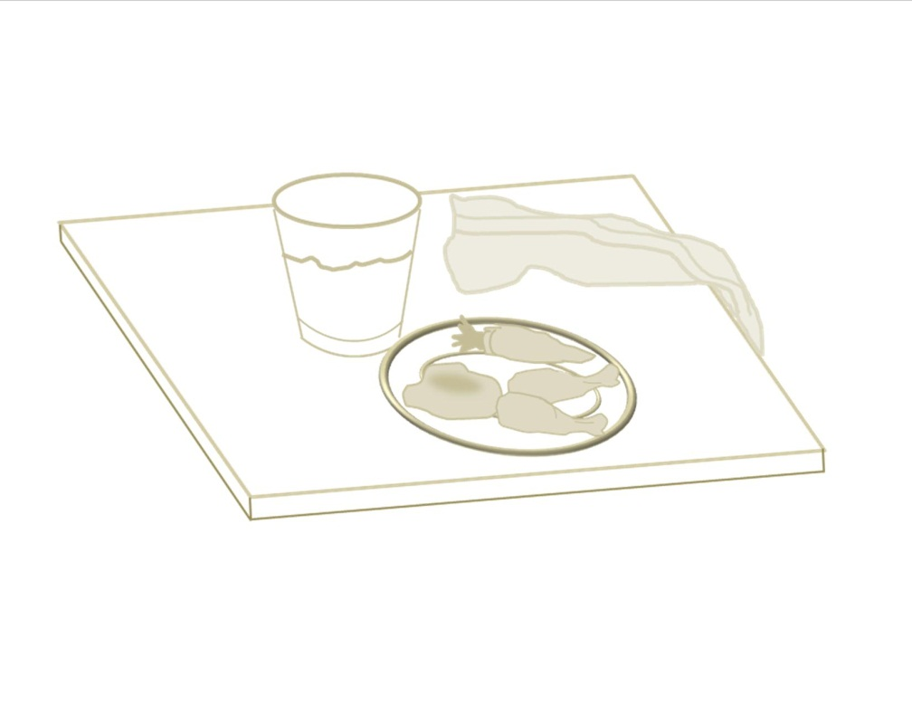

Demonstration Name: Tablecloth VS. Inertia

Concept: Inertia/1st Law of Motion

Materials:

* Sheet (cut)
* Kitchenware (plate, bowl, glass, clay and food)
* Safety glasses
* Water
* Towels

Chapter (page(s) in text): __________

Notes: _______________________________________________ _______________________________________________________________________________________________________________________________________________________________