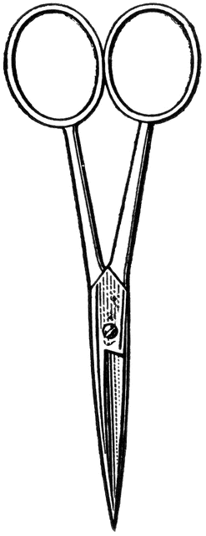
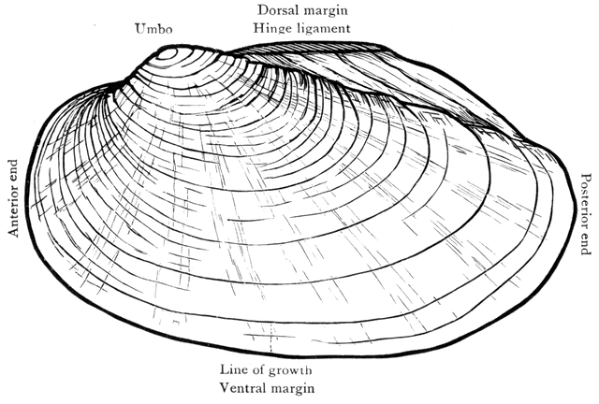
- Lesson Plan: Clam Dissection

Dissection 101:
The Clam
Background: The clam is an invertebrate in the phylum Mollusca; it is a bivalve, having two shells connected by a hinge. The shells provide protection for the clam and are opened and closed by two adductor muscles located on either side of the hinge. The hinge is located on the dorsal side of the clam next to a structure/location called the umbo. The umbo is circular in shape and is the oldest section of the shell. Many times the umbo appears worn with the dark outer layers of the shell removed, exposing the iridescent nacre/mother of pearl. Additional rings are produced by the mantle of the clam as it grows.
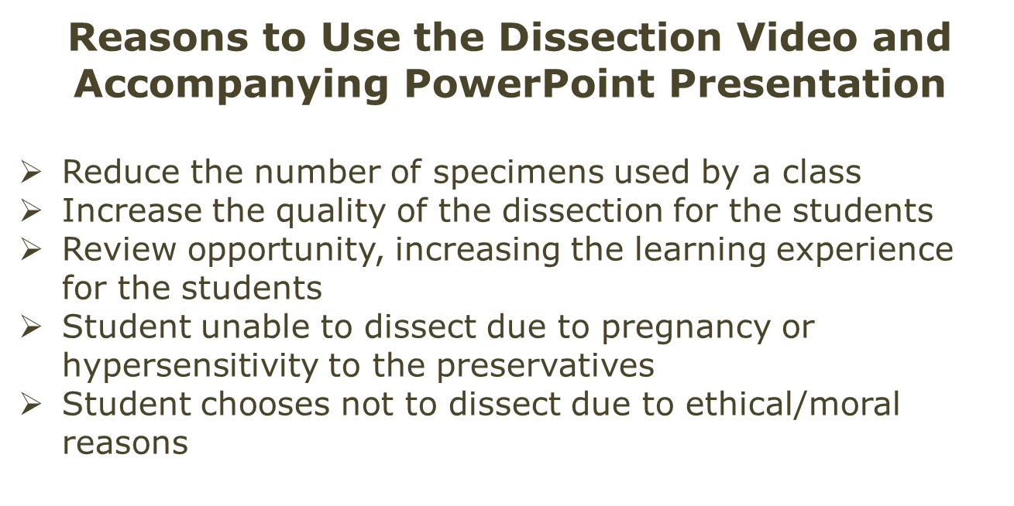
The clam has a complete digestive system with a mouth and anus. Clams are filter feeders, sifting through water and sediment on the bottom of streams, rivers and lakes. They separate the organic material from the inorganic. The clam moves through the sediment with a muscular foot that extends outward from the body, between the two shells. The clam uses the foot to burrow into the sediment.
The clam removes oxygen from the water with gills. The oxygen and nutrients are moved throughout the body with a circulatory system. Unlike the human circulatory system, the clam has an open system resulting in less pressure and efficiency.
Materials:
- Clam dissection PowerPoint (Wait for the “Click” sign in lower right corner)
- Clam quiz PowerPoint (Handout: Teacher/ Student)
- Preservative MSDS for reference
Advance through the PowerPoint slides slowly for the PowerPoint presentations to work properly.
(Wait for the “Click”)

- Eyewash station available
- Shower available
- The following are for each student, pair or group.
    - Dissection tray and pointer
    - Dissection scissors
    - Scalpel
    - Eye protection
    - Protective clothing (apron, lab-coat)
Are you looking for more science resources?
Visit Old School Demonstrations at
http://www.sdpb.org/scienceiq (Click)
    - Gloves (latex free)
Dissection 101:
Freshwater Clam (continue – page 2)
    - Clam identification Handout
(One for use in lab, extra copy for reference)
    - Clams
      - Example biological suppliers
        - WARDS (http://wardsci.com)
        - Carolina (http://www.carolina.com)
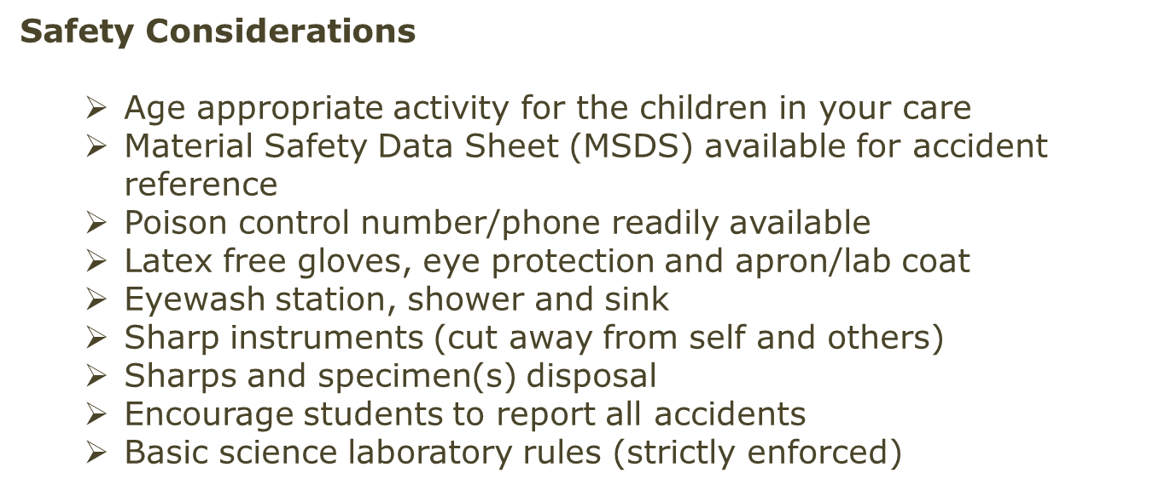

Procedure:
  - The teacher should view the accompanying dissection Video.
(The video is not designed to be viewed by the students; it is designed for the teacher to review the dissection. The students may view the video if appropriate/necessary.)
    - Video time code:
        - Time: 00:00 to 02:50 – Clam basics/orientation
        - Time: 02:50 to 17:59 – Clam dissection
  - Gather the materials listed above.
    - Include the interactive PowerPoint presentation for the laboratory projector/screen.
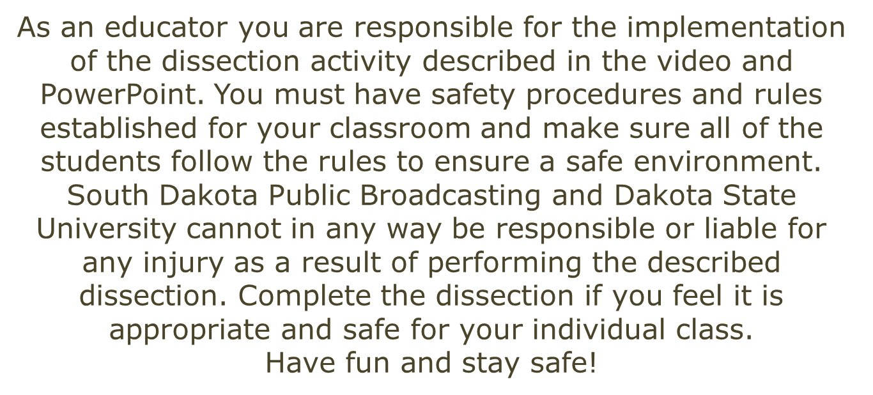
  - Review safety concerns/rules with students.
  - Lead the dissection by advancing through the PowerPoint presentation; the students should identify the parts shown.
  - The students should check off the clam parts on the student Handout once they are identified. An extra, clean copy should be given to the students for review.
  - Clean the laboratory and dispose of specimens properly.
  - Quiz the students during the next class period.
    - Save the clams and pin the actual parts.
    - Clam quiz PowerPoint (Handout: Teacher/ Student)
Images courtesy FCIT, http://etc.usf.edu/clipart

Are you looking for more science resources?
Visit Old School Demonstrations at
http://www.sdpb.org/scienceiq (Click)

