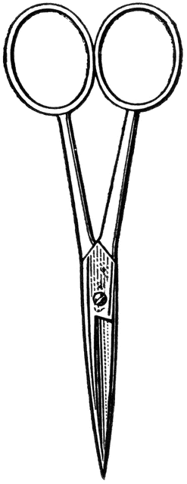
Name: ______________

Dissection 101: Clam
Student Checklist
Clam Checklist: Identify the following structures/locations.

- Use lines provided for additional notes
- Outside structures/locations
- Umbo (location): Shell originates from here, oldest section of the shell
________________________________________________________
________________________________________________________
- Orientation
  - Anterior (closer to umbo) ______________________________
___________________________________________________
  - Dorsal (hinge side)____________________________________
___________________________________________________
  - Posterior (greater distance from umbo) ___________________
___________________________________________________
  - Ventral (foot side - movement)__________________________
___________________________________________________
  - Hinge: Connection of shells (bivalve) ________________________________________________
  - Label drawing

Provided by
- Inside structures/locations
Name: ______________
Dissection 101: Clam
Student Checklist (Continue page 2)
  - Adductor muscles: relaxed – clam opens; contracted – clam closes
_____________________________________________________
____________________________________________________
  - Mantle: Produces shell, provides protective and lubricated surface for the body structures __________________________________
_____________________________________________________
  - Pallial line: Location on shell where mantle attaches ___________
_____________________________________________________
  - Nacre/Mother of pearl: Iridescent layer of the shell, pearls form here _________________________________________________
_____________________________________________________
  - Labial palps (4): Two on each side of the mouth, used to sort food and move it toward the mouth for digestion__________________
_____________________________________________________
  - Muscular Foot: Used for movement, appears shrunken in preserved clam _________________________________________________
_____________________________________________________
  - Gills (respiratory): Used to remove oxygen from the water and helps move food toward labial palps ________________________
_____________________________________________________
  - Visceral mass: Thick area above foot, digestive glands, intestines and gonads located here _________________________________
_____________________________________________________
  - Digestive glands (usually greenish): Produces enzymes to digest food _________________________________________________
_____________________________________________________
  - Gonads (usually yellowish/white): reproduction _______________
_____________________________________________________
  - Intestines (tube-like): Located through the visceral mass, especially noticeable in the gonad region_____________________
_____________________________________________________
  - Heart: Pumps blood throughout the clam, open circulatory system (blood pools around heart) _______________________________
_____________________________________________________

Provided by
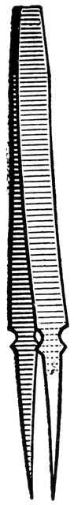
Name: ______________
Dissection 101: Clam
Student Checklist (Continue page 3)
  - Draw and label the inside of the clam with the following structures.

Nacre/Mother of pearl Pallial line Adductor muscles Mantle Labial palps Gills Muscular Foot Visceral mass Digestive glands Heart Intestines Gonads

Images courtesy FCIT, http://etc.usf.edu/clipart

Provided by

