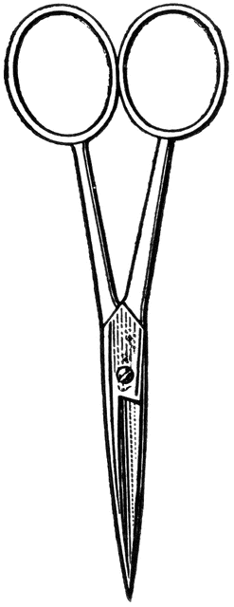

Dissection 101: Clam
PowerPoint Quiz (student)
Clam Dissection Quiz: Complete the following questions.

- Which of the following is the ventral side of the clam?
Side: A B C D (circle one)

- Name the location indicated on the shell? _______________

- Name the structure indicated above. _______________

- What is the function of this structure?
________________________________________________________________________________________________________________

- Name the structure indicated. _______________

- What is the function of this structure?
________________________________________________________________________________________________________________

- Name the structure indicated. _______________

- What is a function of this structure?
________________________________________________________________________________________________________________

- Name the structure indicated. _______________

- What type of circulatory system does the clam have?
Open system Closed system (circle one)
Provided by
Dissection 101: Clam
PowerPoint Quiz Continue (student)
- Describe how the clam’s circulatory system compares/contrasts to the human circulatory system.
________________________________________________________________________________________________________________________________________________________________________________________________________________________________

- Name the structure indicated. _______________

- What is a function of this structure?
________________________________________________________________________________________________________________

- What is the function of the green section indicated?
________________________________________________________________________________________________________________

- Name the tube-like structure indicated. _______________
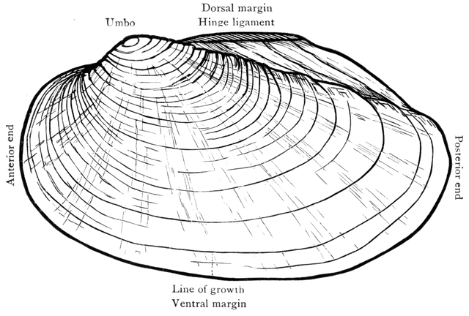
Provided by

