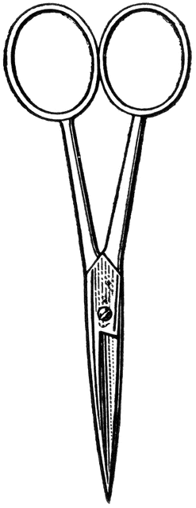

Dissection 101: Earthworm
Student Checklist
Name: ______________
Earthworm Checklist: Identify the following structures/locations.

- Use lines provided for additional notes to aid in future identification
- Outside structures/locations/orientation

- Clitellum (location): Noticeable belt/Band-Aid like section toward the anterior end of the earthworm; produces slime-tube/cocoon during reproduction______________________________________________________________________________________________________
- Anterior (closer to clitellum, thicker/larger circumference)__________ ________________________________________________________________________________________________________________
- Posterior (greater distance from clitellum)_______________________ ________________________________________________________
- Mouth: Fold at anterior end, deposit feeder _____________________ ________________________________________________________
- Ventral (usually lighter in color, hair-like setae - feels like sandpaper ) ________________________________________________________________________________________________________________
- Dorsal (usually darker in color)________________________________ ________________________________________________________
- Segmentation: Distinguished on the exterior by noticeable band-like rings; internally the segments are separated by septa _____________ ________________________________________________________
- Draw and label the earthworm (Label: clitellum, anterior, posterior, ventral, dorsal, segments, setae, mouth)

Provided by
Dissection 101: Earthworm
Student Checklist (Continue page 2)
Name: ______________
- Inside structures/locations

  - Dorsal blood vessel: Movement of blood by pumping action
_____________________________________________________
_____________________________________________________

  - Aortic arches: Often referred to as the heart, pressure regulation __________________________________________________________________________________________________________

  - Seminal vesicles: Storage of sperm produced by the worm _______ _____________________________________________________

  - Seminal receptacles: Storage of sperm received from another worm ______________________________________________________ _____________________________________________________
  - Nerve cord: Tube-like structure found on ventral surface, usually white/cream in color, sensory function ______________________ _____________________________________________________
  - Pharynx: Swallows food (soil), muscular tube, connects mouth to esophagus _____________________________________________ _____________________________________________________
  - Esophagus: Movement of food (soil) toward crop, lies below aortic arches _______________________________________________ _____________________________________________________
  - Crop: Food storage, similar to the stomach of a vertebrate, thin walled ________________________________________________ _____________________________________________________
  - Gizzard: Grinds food, thick walled, muscular___________________
_____________________________________________________
  - Intestine: Food digestion and nutrient absorption_______________
_____________________________________________________
Provided by
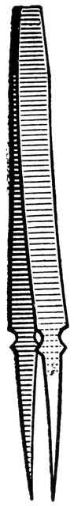
Name: ______________
Dissection 101: Clam
Student Checklist (Continue page 3)

- Draw and label the inside of the earthworm with the following structures

Dorsal blood vessel Aortic arches Seminal vesicles
Seminal receptacles Nerve cord Pharynx
Esophagus Crop Gizzard
Intestine

Images courtesy FCIT, http://etc.usf.edu/clipart

Provided by

