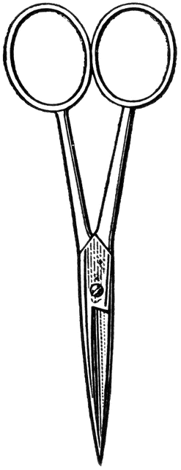

Dissection 101: Earthworm
PowerPoint Quiz (student)
Earthworm Dissection Quiz: Complete the following questions.

- Which earthworm above is displaying the ventral surface?
Earthworm: A B (circle one)

- Name the structure indicated? Clitellum

- What is the function of this structure?
Clitellum produces a slime-like tube which forms the cocoon. (A slime tube is produced by the clitellum and passes over the worm collecting the eggs and the stored sperm from the mate. The eggs are fertilized in the slime tube which slides off of the worm and forms a cocoon for the fertilized eggs.)

4. What is the dark, black material shown above? Dirt

5. Name the structure indicated. Aortic arches

6. What type of circulatory system does the earthworm have?
A. Open system B. Closed system (circle one)

7. Name the structure indicated. Seminal receptacle

8. What is the function of this structure?
Store sperm received from another worm.

9. Name the structure indicated. Crop

10. What is the function of this structure?
Food storage

11. Gender - viewing the earthworm below; which of the following is correct?
A. Female B. Male C. Both (circle one)

12. Name the structure indicated. Gizzard

13. What is a function of this structure?
Grind/break down food
Provided by

Dissection 101: Earthworm
PowerPoint Quiz Continue (student)

14. Which system is this structure associated with?
A. Digestive B. Nervous C. Reproductive D. Circulatory (circle one)

15. Describe the movement of the earthworm using the following terms.
(Setae, circular muscles, longitudinal muscles, segments)
There are tiny hair-like structures on the segments called setae which aid in movement. Circular muscles are used to reduce the circumference of the earthworm, increasing the length of a section. The setae secure the section to the surroundings and then longitudinal muscles contract reducing the length of the worm. The segments are able to move independent of each other resulting in the characteristic seesaw-like motion of the earthworm.

Provided by

