Old School Science Demonstrations!

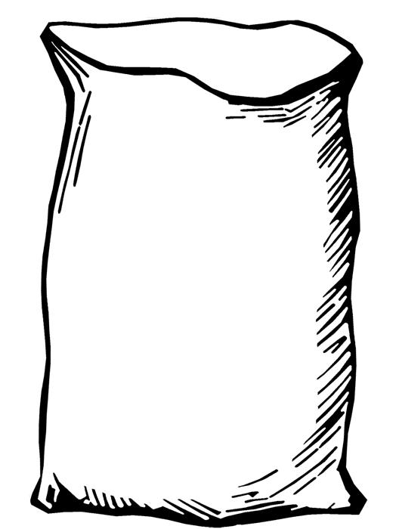

Demonstration Name: Bernoulli's Bag

Concept: Matter, air flow, fluid

Materials:

* Long plastic tube(s)
  + Different names, depending on supplier (Bernoulli’s bag, WindTube, Bernoulli’ tube)
    - One supplier (http://www.teachersource.com/product/windtubes/air-pressure)
    - A garbage bag also works, but the demo is not as effective.

Chapter (page(s) in text): __________

Notes: _______________________________________________ __________________________________________________________________________________________________________

Image courtesy FCIT, <http://etc.usf.edu/clipart>

& Microsoft Clipart.

Images courtesy FCIT, <http://etc.usf.edu/clipart>

& Microsoft Clipart.