Old School Science Demonstrations!

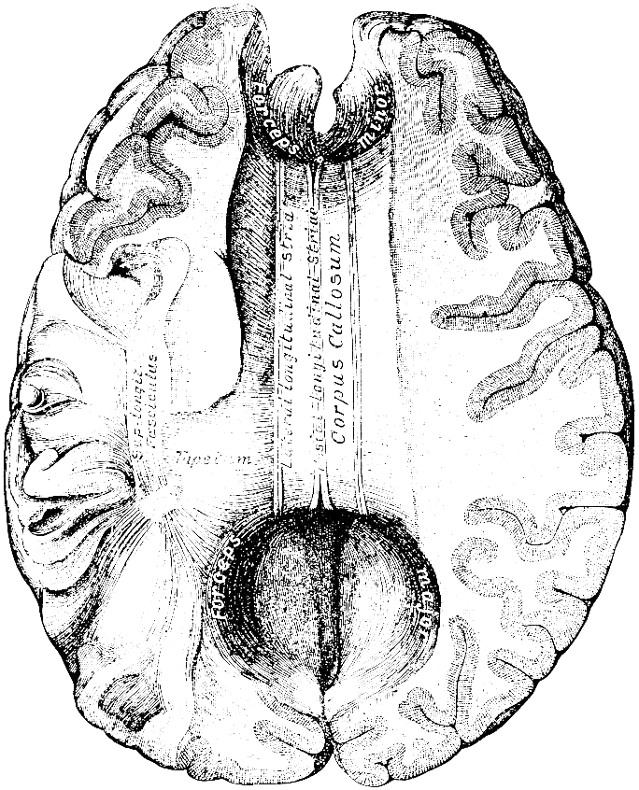

Demonstration Name: Are You Connected?

Concept: Corpus Callosum

Materials:

* PowerPoint
* Projector
* Computer
* Pencil (2)/ Paper
* Box (cut for hands)
* Internet to view related video

Chapter (page(s) in text): __________

Notes: _______________________________________________ _______________________________________________________________________________________________________________________________________________________________